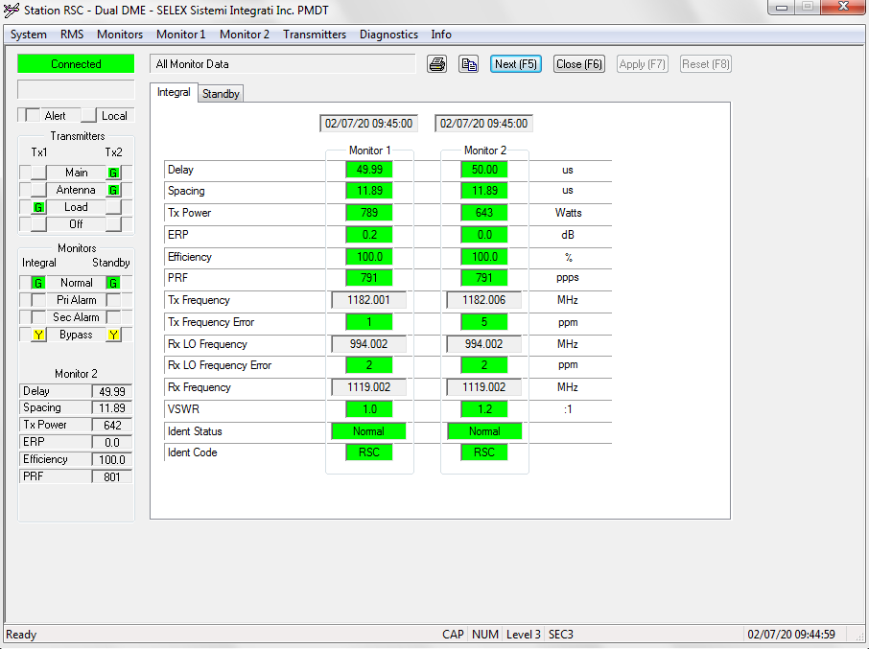

[09:44:41.017] F8 F8 B0 F0 08 00 00 00 00 34 00 14 02 07 09 2C 28 00 00 80 07 24 00 01 8C 06 39 8A 01 19 BC 87 13 A5 04 88 02 E8 03 67 07 00 00 00 00 00 00 00 00 00 00 06 01 00 00 06 00 00 C4 D2 23 D7 66 2A 91

*Main Tx2*

*Ant Tx2*

*Tx1 LOAD*

*Tx1 ON*

*Tx2 ON*

*Dual Equipment*

*IntMonBypass*

*Integral Bypass*

*Standby Bypass*

*eMain*

*No Go condition ALARM*

*Ngay 7 thang 2 nam 20 Gio 9 Phut 44 Giay 40*

*DME Delay: 4999 us,Spacing: 1189 us,TxPower: 648 Watts,Efficiency :1000 %,PRF: 1895 ppps,ERP: 1*

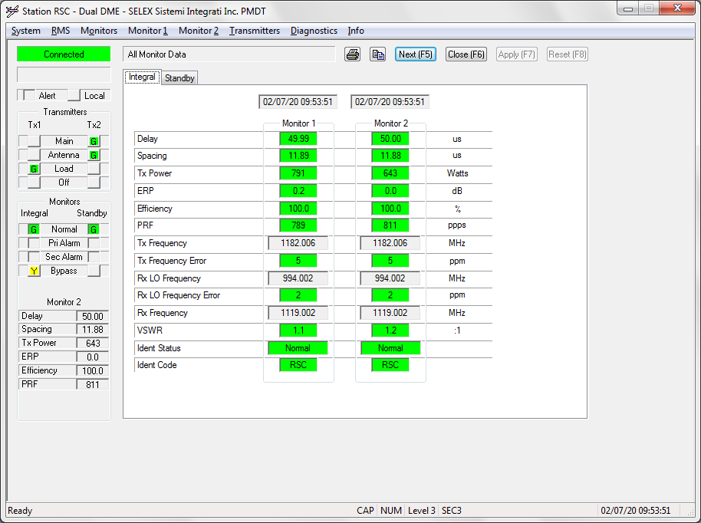

[09:53:20.421] F8 F8 B0 F0 08 00 00 00 00 34 00 14 02 07 09 35 15 00 00 80 07 04 00 01 8C 06 39 8A 01 19 BC 88 13 A5 04 85 02 E8 03 19 03 00 00 00 00 00 00 00 00 00 00 06 00 00 00 06 00 00 1F B0 EE D7 66 A2 D5

Main Tx2

Ant Tx2

Tx1 LOAD

Tx1 ON

Tx2 ON

Dual Equipment

IntMonBypass

Integral Bypass

eMain

No Go condition ALARM

Ngay 7 thang 2 nam 20 Gio 9 Phut 53 Giay 21

DME Delay: 5000 us,Spacing: 1189 us,TxPower: 645 Watts,Efficiency :1000 %,PRF: 793 ppps,ERP: 0

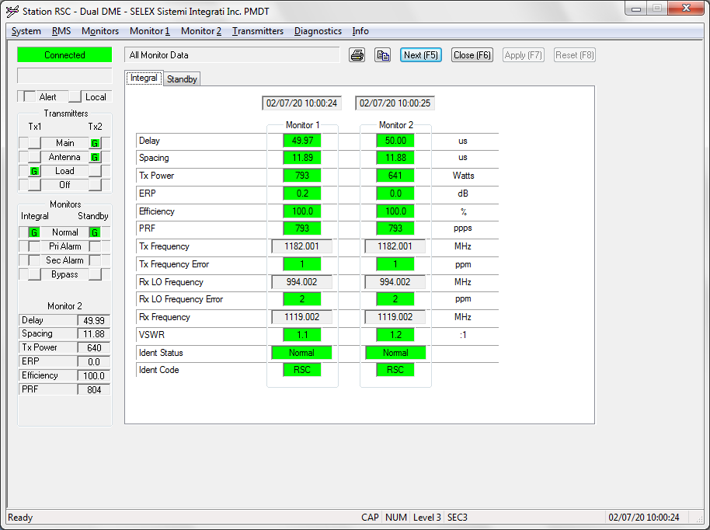

[10:00:21.648] F8 F8 B0 F0 08 00 00 00 00 34 00 14 02 07 0A 00 16 00 00 80 07 00 00 01 8C 06 39 8A 01 19 BC 86 13 A5 04 81 02 E8 03 25 03 00 00 00 00 00 00 00 00 00 00 06 01 00 00 06 00 00 28 32 93 D8 66 70 CC

Main Tx2

Ant Tx2

Tx1 LOAD

Tx1 ON

Tx2 ON

Dual Equipment

eMain

Go condition

Ngay 7 thang 2 nam 20 Gio 10 Phut 0 Giay 22

DME Delay: 4998 us,Spacing: 1189 us,TxPower: 641 Watts,Efficiency :1000 %,PRF: 805 ppps,ERP: 1

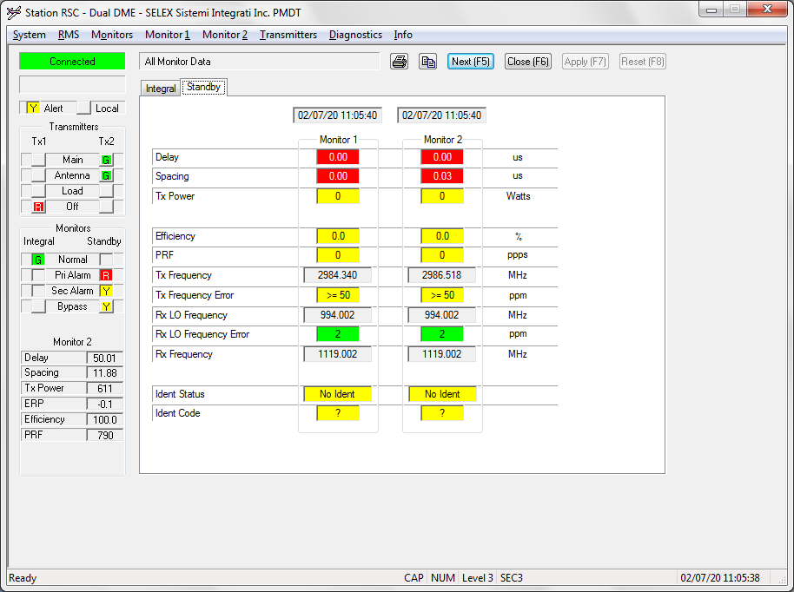

[11:05:31.854] F8 F8 B0 F0 08 00 00 00 00 34 00 14 02 07 0B 05 21 00 00 81 07 28 02 01 88 06 39 8A 01 19 BC 8A 13 A4 04 63 02 E8 03 2F 03 00 00 00 00 00 00 00 00 00 00 06 FF 00 00 06 00 00 74 59 8A DE 66 77 0A

Alert

Main Tx2

Ant Tx2

Tx1 OFF

Tx2 ON

Dual Equipment

Standby PriAlarm

Standby SecAlarm

Standby Bypass

eMain

Go condition

Ngay 7 thang 2 nam 20 Gio 11 Phut 5 Giay 33

DME Delay: 5002 us,Spacing: 1188 us,TxPower: 611 Watts,Efficiency :1000 %,PRF: 815 ppps,ERP: -1

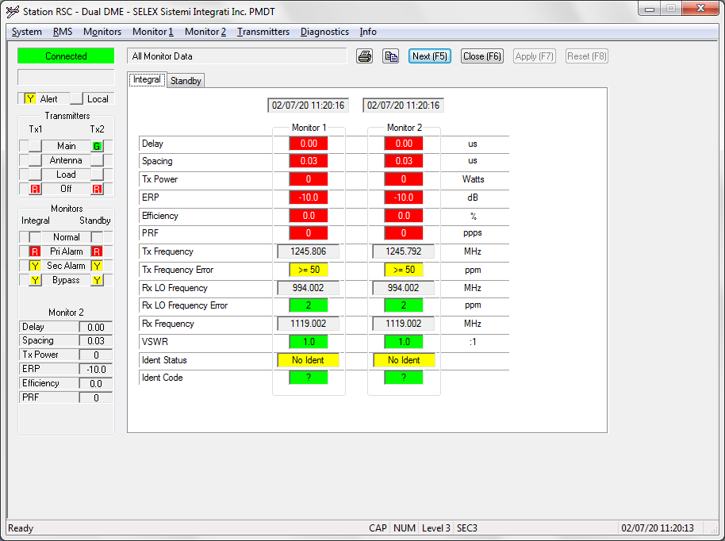

[11:20:13.586] F8 F8 B0 F0 08 00 00 00 00 34 00 14 02 07 0B 14 0D 00 00 81 07 2D 03 01 90 06 39 8A 01 19 BC 00 00 03 00 00 00 00 00 00 00 00 00 00 00 00 00 00 00 00 00 06 9C 00 00 06 00 00 3D CA 8E D5 66 C2 88

Alert

Dual Equipment

Main Tx2

Tx1 OFF

Tx2 OFF

Integral PriAlarm

Integral SecAlarm

Integral Bypass

Standby PriAlarm

Standby SecAlarm

Standby Bypass

eOFF

No Go condition ALARM

Ngay 7 thang 2 nam 20 Gio 11 Phut 20 Giay 13

DME Delay: 0 us,Spacing: 3 us,TxPower: 0 Watts,Efficiency :0 %,PRF: 0 ppps,ERP: -100

H6

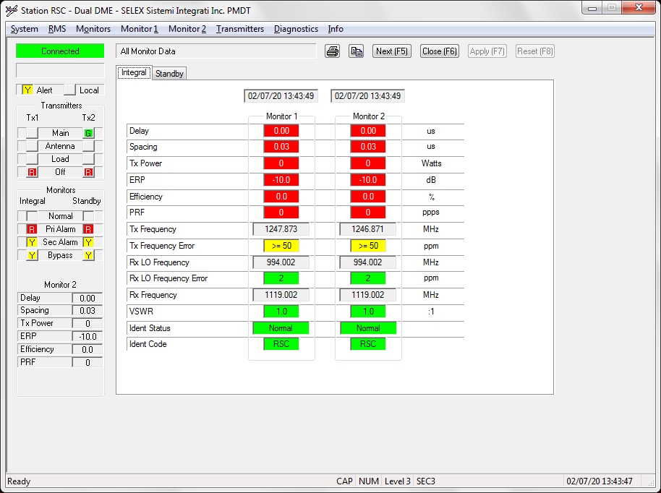

[13:43:56.725] F8 F8 B0 F0 08 00 00 00 00 34 00 14 02 07 0D 2B 39 00 00 81 07 2D 03 01 90 06 39 8A 01 19 BC 00 00 03 00 00 00 00 00 00 00 00 00 00 00 00 00 00 00 00 00 06 9C 00 00 06 00 00 25 FF 77 D6 66 C5 ED

*Alert*

*Dual Equipment*

*Main Tx2*

*Tx1 OFF*

*Tx2 OFF*

*Integral PriAlarm*

*Integral SecAlarm*

*Integral Bypass*

*Standby PriAlarm*

*Standby SecAlarm*

*Standby Bypass*

*eOFF*

*No Go condition ALARM*

*Ngay 7 thang 2 nam 20 Gio 13 Phut 43 Giay 57*

*DME Delay: 0 us,Spacing: 3 us,TxPower: 0 Watts,Efficiency :0 %,PRF: 0 ppps,ERP: -100*

H7

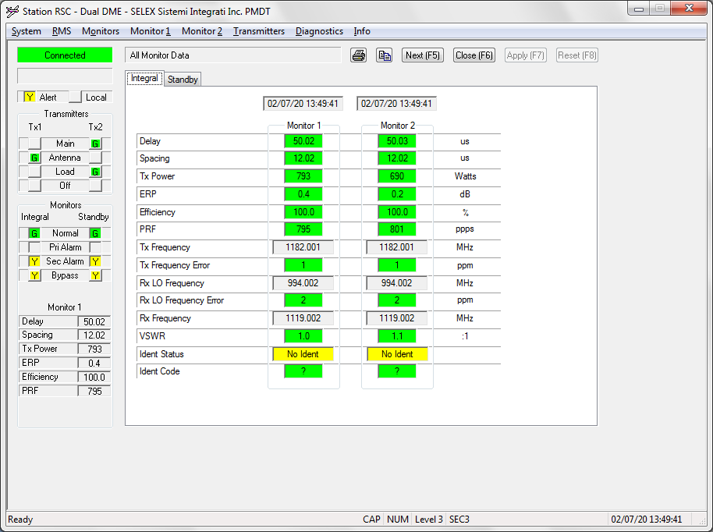

[13:49:25.769] F8 F8 B0 F0 08 00 00 00 00 34 00 14 02 07 0D 31 1A 00 00 81 27 24 03 01 9D 06 39 8A 01 19 BC 8A 13 B2 04 1B 03 E8 03 1B 03 00 00 00 00 00 00 00 00 00 00 06 04 00 00 06 00 00 CD BC 9F D4 66 0A A0

Alert

Dual Equipment

Main Tx2

Ant Tx1

Tx2 LOAD

Tx1 ON

Tx2 ON

Integral SecAlarm

Integral Bypass

Standby SecAlarm

Standby Bypass

eSTANDBY

No Go condition ALARM

Ngay 7 thang 2 nam 20 Gio 13 Phut 49 Giay 26

DME Delay: 5002 us,Spacing: 1202 us,TxPower: 795 Watts,Efficiency :1000 %,PRF: 795 ppps,ERP: 4

H8

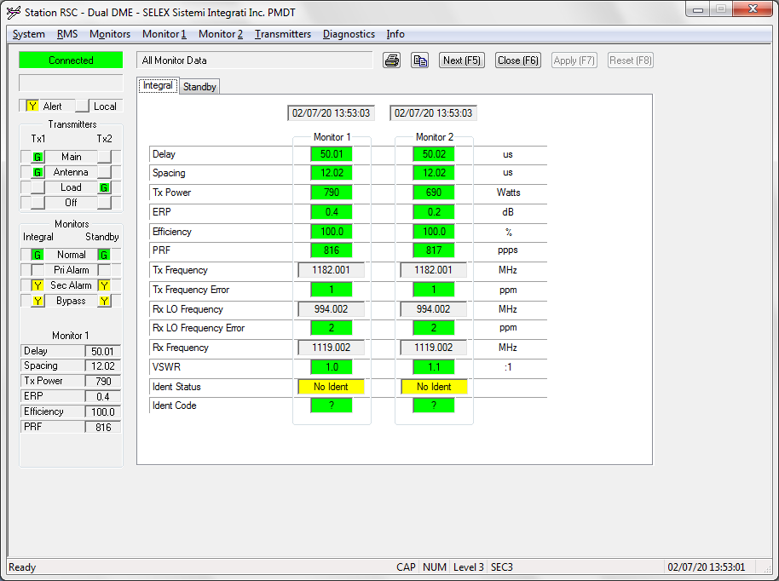

[13:53:08.649] F8 F8 B0 F0 08 00 00 00 00 34 00 14 02 07 0D 35 08 00 00 81 27 24 03 01 9F 06 39 8A 01 19 BC 89 13 B2 04 17 03 E8 03 1E 03 00 00 00 00 00 00 00 00 00 00 06 03 00 00 06 00 00 44 C8 F6 D4 66 8B 6A

*Alert*

*Dual Equipment*

*Main Tx1*

*Ant Tx1*

*Tx2 LOAD*

*Tx1 ON*

*Tx2 ON*

*Integral SecAlarm*

*Integral Bypass*

*Standby SecAlarm*

*Standby Bypass*

*eMain*

*No Go condition ALARM*

*Ngay 7 thang 2 nam 20 Gio 13 Phut 53 Giay 8*

*DME Delay: 5001 us,Spacing: 1202 us,TxPower: 791 Watts,Efficiency :1000 %,PRF: 798 ppps,ERP: 3*

H9

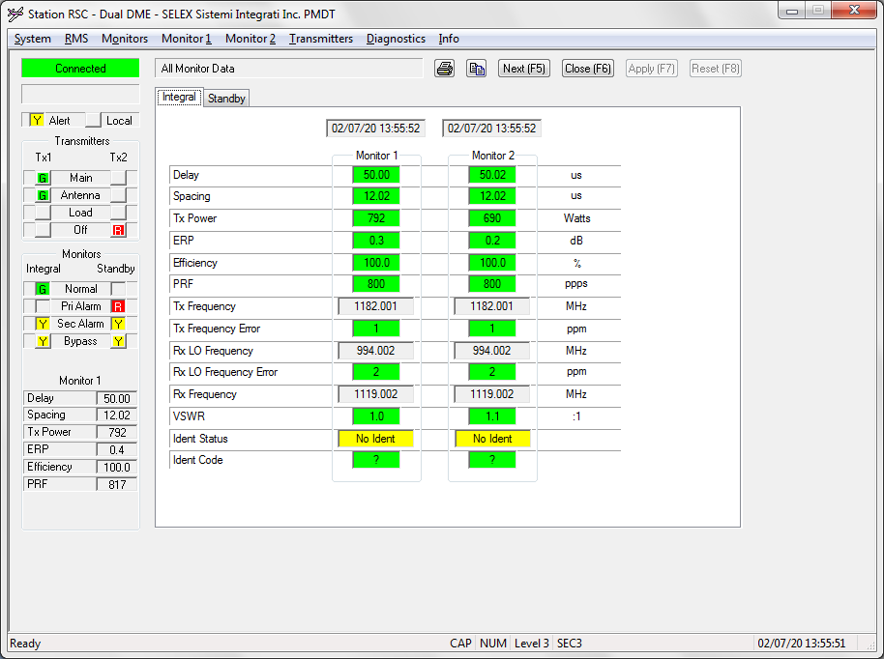

[13:55:45.431] F8 F8 B0 F0 08 00 00 00 00 34 00 14 02 07 0D 37 2E 00 00 81 27 2C 03 01 97 06 39 8A 01 19 BC 89 13 B2 04 16 03 E8 03 2F 03 00 00 00 00 00 00 00 00 00 00 06 04 00 00 06 00 00 7A 02 34 D5 66 21 F6

Alert

Dual Equipment

Main Tx1

Ant Tx1

Tx1 ON

Tx2 OFF

Integral SecAlarm

Integral Bypass

Standby PriAlarm

Standby SecAlarm

Standby Bypass

eMain

No Go condition ALARM

Ngay 7 thang 2 nam 20 Gio 13 Phut 55 Giay 46

DME Delay: 5001 us,Spacing: 1202 us,TxPower: 790 Watts,Efficiency :1000 %,PRF: 815 ppps,ERP: 4

H10

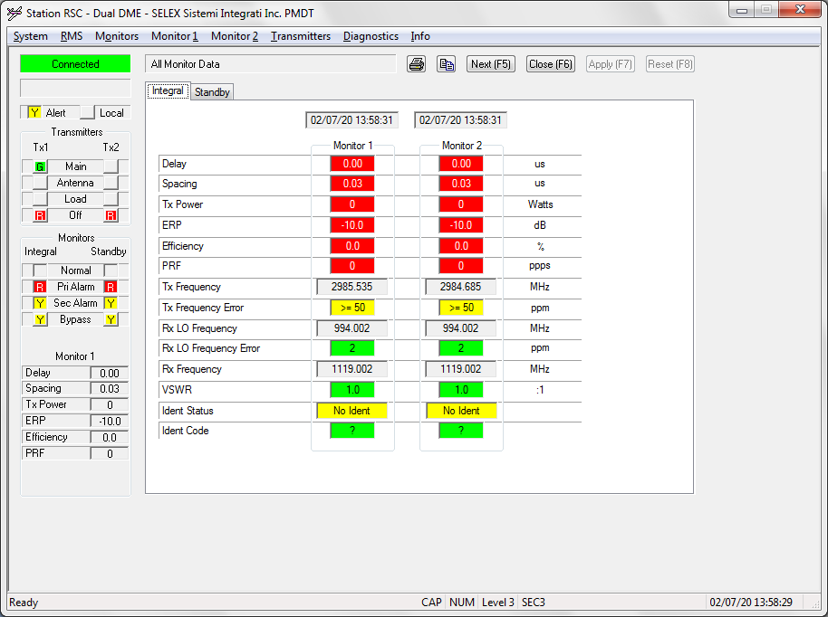

[13:58:41.232] F8 F8 B0 F0 08 00 00 00 00 34 00 14 02 07 0D 3A 2A 00 00 81 27 2D 03 01 93 06 39 8A 01 19 BC 00 00 03 00 00 00 00 00 00 00 00 00 00 00 00 00 00 00 00 00 06 9C 00 00 06 00 00 58 AA 78 D5 66 A2 76

Alert

Dual Equipment

Main Tx1

Tx1 OFF

Tx2 OFF

Integral PriAlarm

Integral SecAlarm

Integral Bypass

Standby PriAlarm

Standby SecAlarm

Standby Bypass

eOFF

No Go condition ALARM

Ngay 7 thang 2 nam 20 Gio 13 Phut 58 Giay 42

DME Delay: 0 us,Spacing: 3 us,TxPower: 0 Watts,Efficiency :0 %,PRF: 0 ppps,ERP: -100